Red VS Blue Cards

This is a simple card game that can be played with **2 players**. There are 20 cards in the deck:

* 10 cards with the label: 0R to 9R. R means Red.
* 10 cards with the label: 0B to 9B. B means Blue.

The game rules are as follows:

1. Each player will receive a set of 7 random cards from the deck.
2. Then each player must choose which **2 cards** to be **removed** from their hand.
3. Finally, players will reveal their hands and compare cards from the first to the last.
4. When comparing cards, the card with **the higher number** will give the owner 1 point. If both cards have the same number, the one with red label will give the owner 1 point.

Andy and Bob are playing this card game. Your job is to create a program that implements the rules above using **Double Linked List.**

For each player, the 7 cards are determined by a 2d char array which contains the card labels. Then insert each label into a double linked list from **left to right** for Andy and Bob.



After creating a double linked list for both players, start giving Andy a chance to remove 2 cards by entering the first and second card label (**case insensitive** & **assume that the input format is correct, and assume the card label exists in the array**). Remove those cards from the linked list and do the same for Bob.

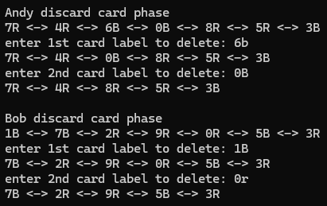

Then start comparing Andy and Bob’s cards starting with the left (head) to the right (tail). Calculate the total points earned for each player based on the rules and declare the winner after.

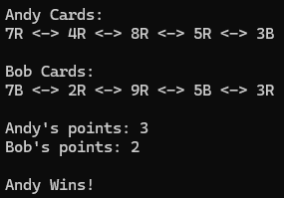

**Explanation:**

1st cards compare: 7R and 7B. same number but, the point goes to Andy because he holds the red card. (Andy: 1, Bob: 0)

2nd cards compare: 4R and 2R. 4 is higher so the point goes to Andy. (Andy: 2, Bob: 0)

3rd cards compare: 8R and 9R. 9 is higher so the point goes to Bob. (Andy: 2, Bob: 1)

4th cards compare: 5R and 5B. same number but, the point goes to Andy because he holds the red card. (Andy: 3, Bob: 1)

5th cards compare: 3B and 3R. same number but, the point goes to Bob because he holds the red card. (Andy: 3, Bob: 2)

And because Andy has higher points than Bob, Andy wins.

**Other test case:**

**Andy: "6R", "2B", "9R", "1B", "8B", "1R", "9B". Remove: "6R", "9R"**   
**Bob:**  **"5B", "6B", "3R", "8R", "7R", "5R", "3B". Remove: "3R", "3B"**  
**winnner: Bob**  
  
**Andy: "7R", "4B", "3R", "6B", "8R", "3B", "5R". Remove: "7R", "5R"**   
**Bob:**  **"4R", "2B", "1B", "6R", "0R", "2B", "7B". Remove: "4R", "7B"**  
**winnner: Andy**